
Land Information Ontario (LIO) Warehouse
Data Class Name: Constructed Drain
Documentation
Produced by: Information Access and Information Management Policy Unit
Ministry of Natural Resources and Forestry
Date: July 27, 2015

Purpose

This document provides additional information to support the use of geospatial data. The Physical Model Diagram provides a visual representation of the relationships in the data class. The Data Change History lists all the modelling and access changes that have occurred during the lifecycle of the data class. A data description identifying table and field names is available upon request.

Need Assistance?
Please contact LIO Support at lio@ontario.ca or 705-755-1878 if you require help.

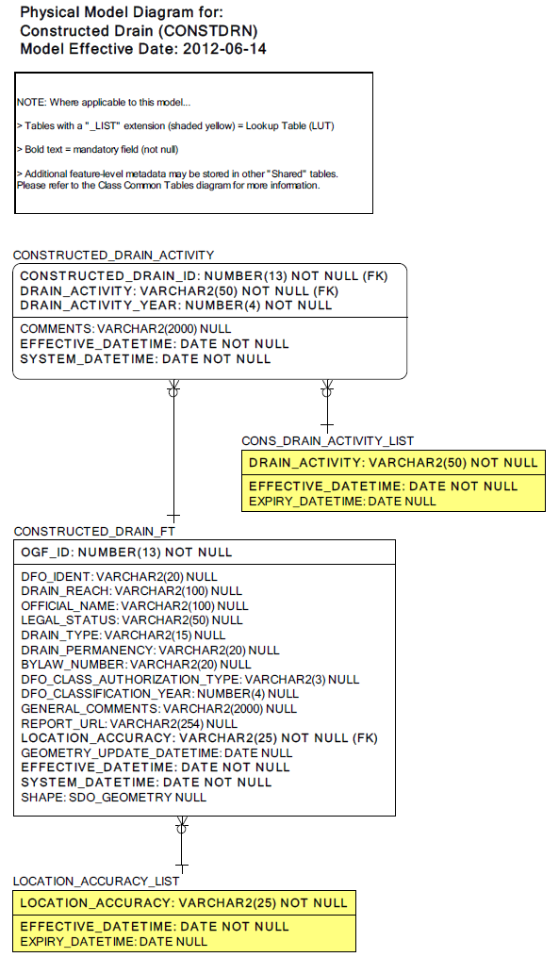
Data Class Change History
Data Class Name: Constructed Drain
Data Class Short Name: CONSTDRN
Date  YYYY-MM-DD | Details of Change
2009-08-06 | Lookup table added: Drain_Activity_List for the types of Drain Activities that can be conducted.
2009-08-06 | Converted to SIMPLE Data Class - Removed GEOG_UNIT table.
2009-08-06 | Column added CONSTRUCTED_DRAIN.GENERAL_COMMENTS  This information is now captured here since GEOGRAPHIC UNIT is no longer being carried.
2009-08-06 | Column added: DRAIN_ACTIVITY.DRAIN_ACTIVITY_YEAR to capture the year in which a specific activity will be occuring on a drain.
2009-08-06 | Column dropped: CONSTRUCTED_DRAIN.THERMAL_REGIME. This will no longer be maintained as part of the business requirements.
2009-08-06 | Column dropped: CONSTRUCTED_DRAIN.LAST_CLEANOUT_YEAR as this information will now be captured in the DRAIN_ACTIVITY.DRAIN_ACTIVITY_YEAR field.
2009-08-06 | Check Constraint added to CONSTRUCTED_DRAIN.DRAIN_LEGAL_STATUS  Added the value 'Natural' to the list of valid values. This is to reflect the business requirement to capture watercourses that have had no anthropogenic (i.e. human) influences or have been designated as natural watercourses by the courts.
2009-08-06 | Check constraints removed on CONSTRUCTED_DRAIN.DFO_CLASS_AUTHORIZATION_TYPE and updated the Column definition.
2009-08-06 | CONSTRUCTED_DRAIN.SOURCE_ID Column added as foreign key to SOURCE table since we are no longer carrying Geographic Unit.
2009-08-06 | CONSTRUCTED_DRAIN.DRAIN_IDENT Column renamed to DFO_IDENT  This field is used to link to the DFO Drain Classification database and the updated name more accurately reflects its purpose.
2009-08-06 | Column added DRAIN_ACTIVITYDRAIN_ACTIVITY to capture the type of activity that will be occuring on a drain in a specific year.
2009-08-06 | Column added: CONSTRUCTED_DRAIN.SOURCE_DETAIL to capture additional information about the source of the data.
2009-08-06 | Column added DRAIN_ACTIVITY.COMMENTS  Added a Comments field to capture any additional information about a drain activity.
2009-08-06 | Column dropped: CONSTRUCTED_DRAIN.CONSTRUCTION_YEAR. This information will now be captured in the DRAIN_ACTIVITY.DRAIN_ACTIVITY_YEAR field.
2009-08-06 | Column added CONSTRUCTED_DRAIN.REPORT_URL to capture the URL of a constructed drain report.
2009-08-06 | New check constraint valued added to CONSTRUCTED DRAIN.DRAIN_LEGAL_STATUS  Natural: A watercourse that has had no anthropogenic (i.e. human) influences or has been designated as a natural watercourse by the court.
2009-08-06 | Added CONSTRUCTED_DRAIN.JUSTIFICATION_ID Column as foreign key to Justification table added since no longer carrying Geographic Unit.
2009-08-06 | Column added CONSTRUCTED_DRAIN.Location_Accuracy since GEOGRAPHIC UNIT table is no longer being carried.
2009-08-06 | Table Added (1-M): DRAIN_ACTIVITY to capture prescriptions to be carried out in a given year on a constructed drain.
2009-08-06 | Check Constraint value added to CONSTRUCTED_DRAIN.LEGAL_STATUS  Natural: A natural watercourse that has had no anthropogenic (i.e. human) influences or has been designated as a natural watercourse by the court.
2009-08-06 | Column added CONSTRUCTED_DRAIN.DRAIN_REACH
2005 | NEW Data Class

Data Description
Please refer to the metadata record for the data description.

